** STREAM:**

**Resilience**

we’d greatly appreciate your use of this qr code to record attendance for this HRSA funded program



**Positive and Negative Emotion**

INDIVIDUAL ACTIVITY: Critical Positivity Ratio



GROUP ACTIVITY: Discussion

PARTNER ACTIVITY: Active Listening Exercise

**Finding Your Values Compass**

PARTNER ACTIVITY: Active Listening Exercise

Space for writing:

INDIVIDUAL ACTIVITY: Values Clarification

**Example Values**

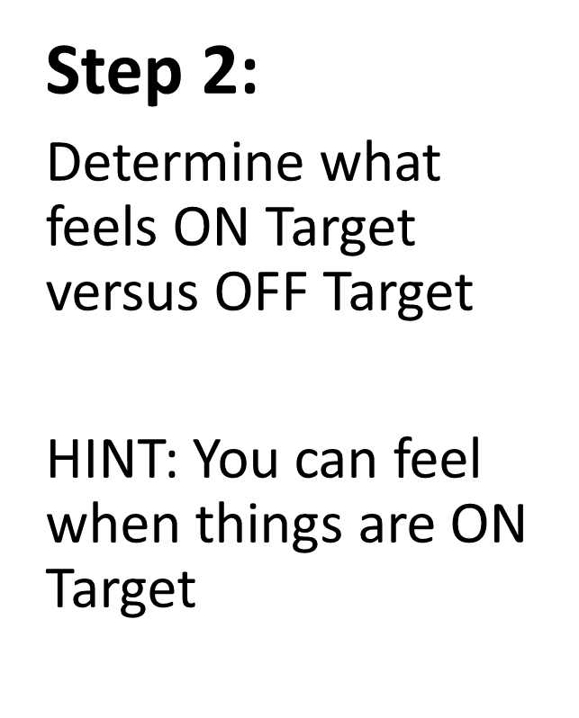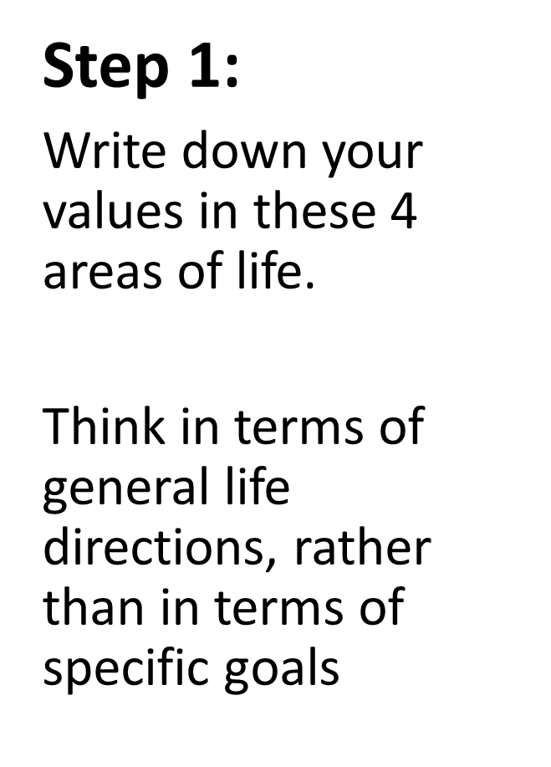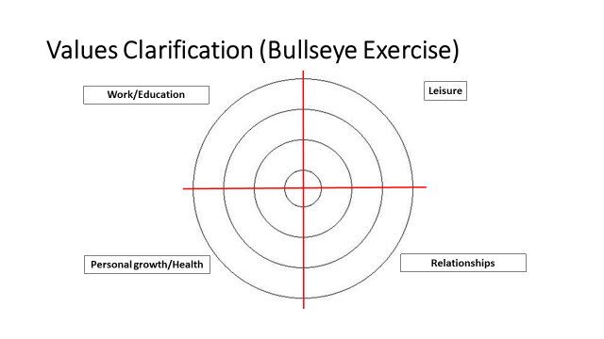

1.

2.

3.

4.

1.

2.

3.

4.

1.

2.

3.

4.

1.

2.

3.

4.

**Ambition**

**Achievement**

**Adventure**

**Bravery**

**Authenticity**

**Community**

**Compassion**

**Competency**

**Connection**

**Curiosity**

**Creativity**

**Dependability**

**Empathy**

**Equity**

**Honesty**

**Humor**

**Integrity**

**Joy**

**Knowledge**

**Justice**

**Leadership**

**Loyalty**

**Optimism**

**Peace**

**Punctionality**

**Respect**

**Responsibility**

**Service**

**Trust**

**Understanding**

**Wisdom**

Debrief: using values to assist in making decisions

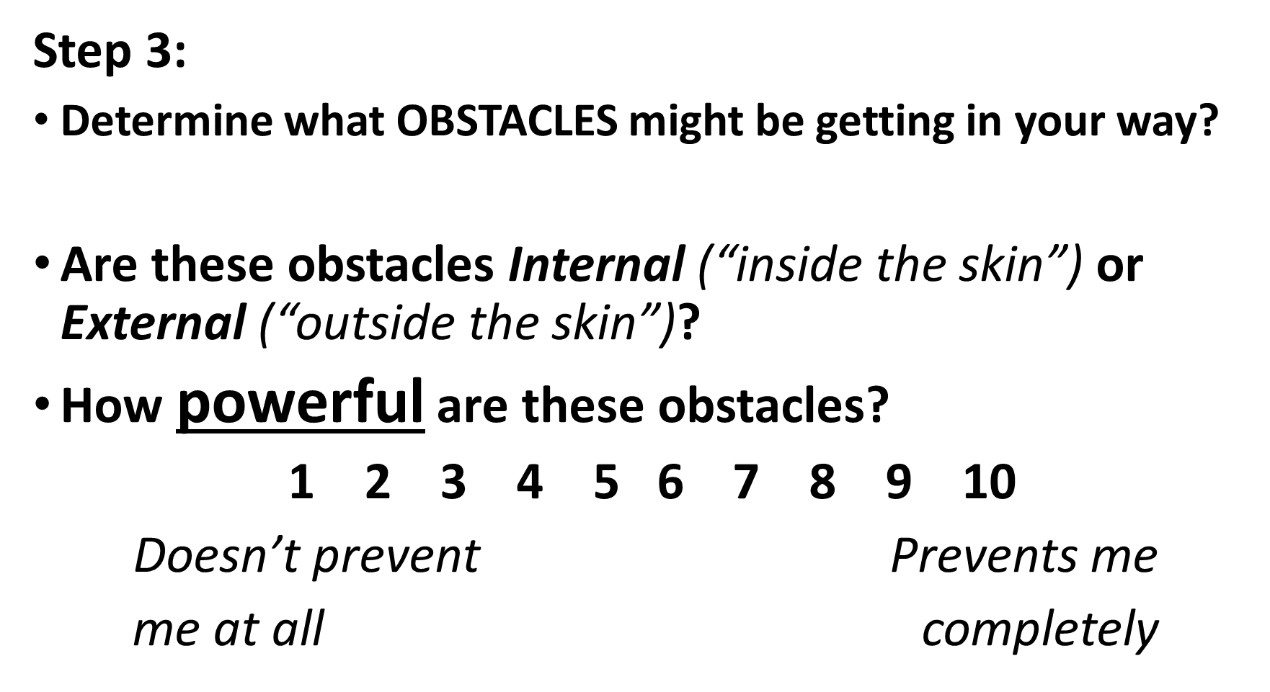

1 2 3 4 5 6 7 8 9 10

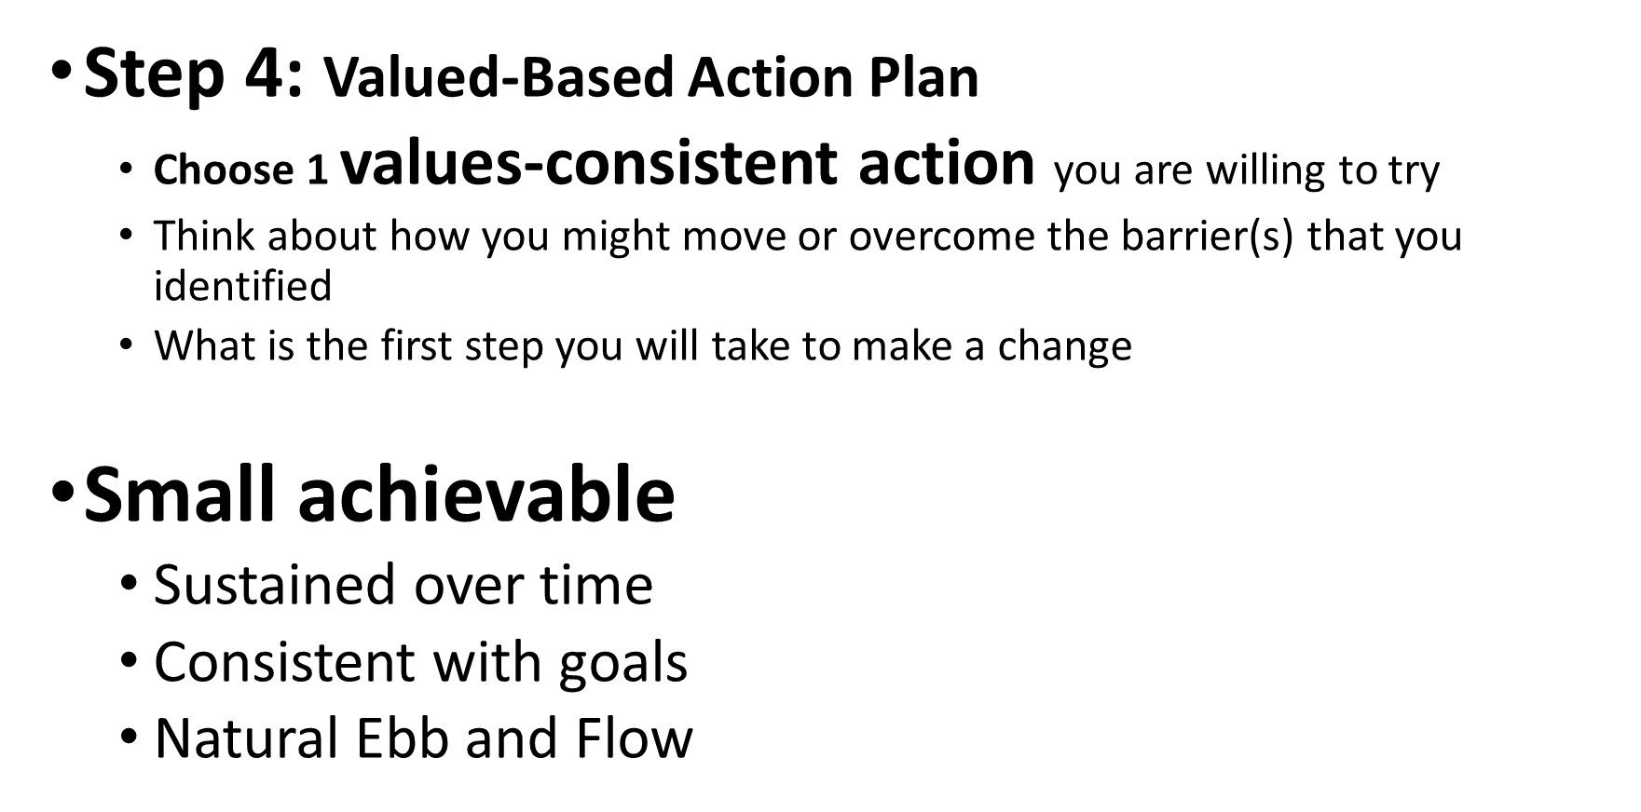

My values-consistent action is… ___________

The first step I will take to make a change is…

Thank You

We’re so glad you could be part of this program with us today. Thank you for your participation!

Please help us out by completing this 6 question evaluation today! We’d love your input re:

Content relevancy, DEI incorporation, interactiveness of session, facilitator effectiveness, likelihood to recommend, and an open ended section for anything you’d like to note.

You’ll receive a follow up survey in two weeks and six months. We’d love your feedback!

Brief Eval



Extra Resources Available to You

STREAM Resource Library

There are extra STREAM resources and activities available for your use on our site as well.  We have more videos, worksheets, and other links that you may find beneficial.  Check them out here:

note: these materials are available for anyone with a STREAM account

Resources



STREAM App

Download our app, available for free

Apple: Android:

 

Features

-Buddy chat (anonymous capability)

-Goal setting and tracking

-Journaling

-Links to extra STREAM resources on the app

-Opportunity to provide feedback for STREAM programming

Follow us on Twitter: STREAM@elms